Payment Processing

Set paymentRule in Malem Organisation

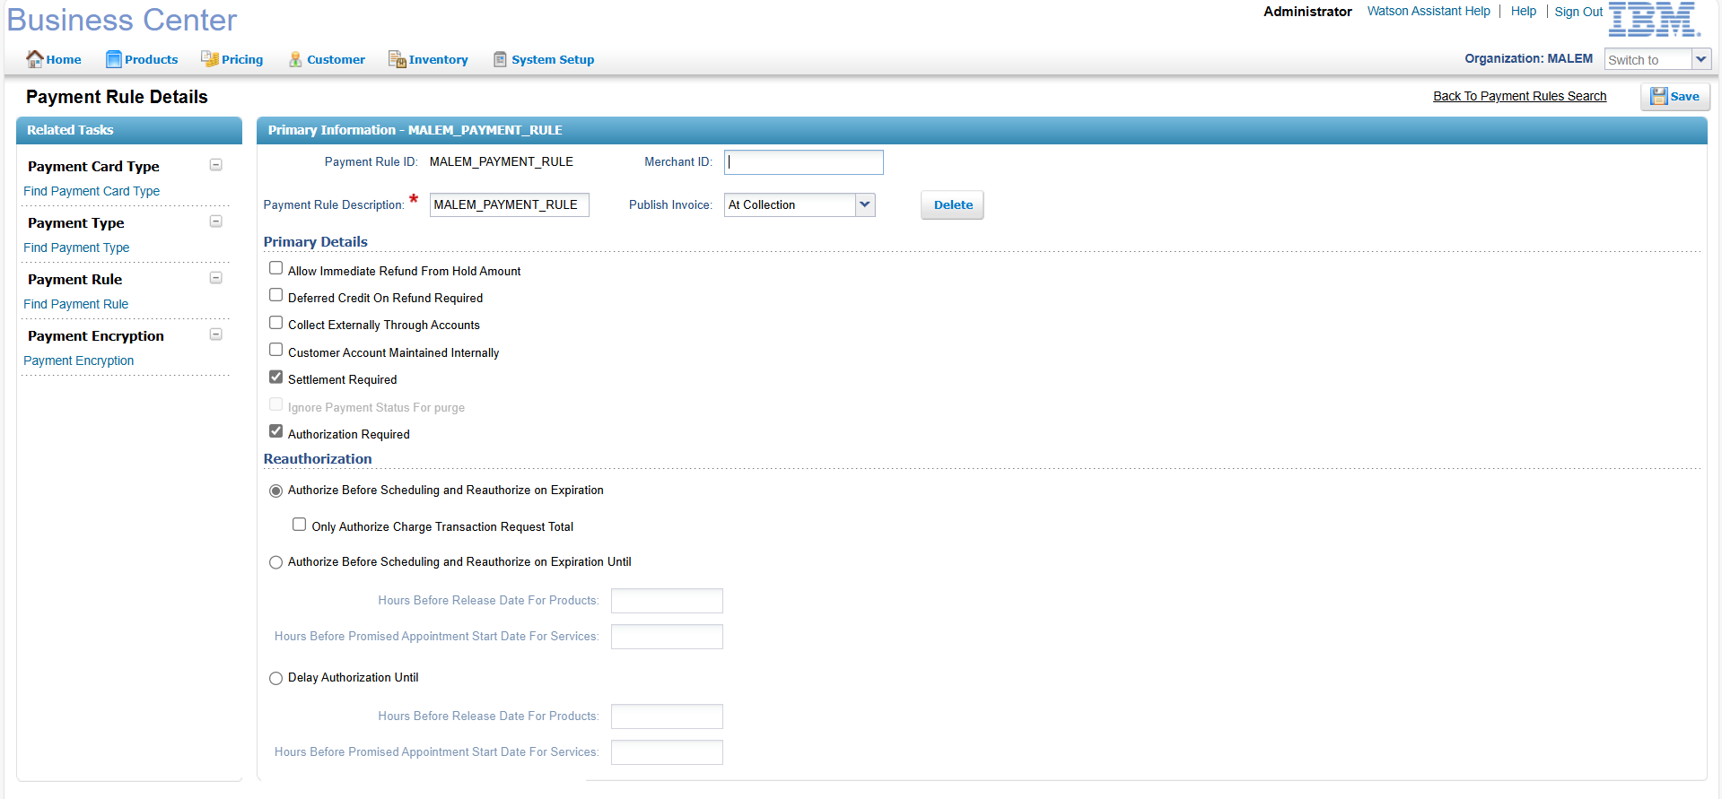

Payment Type

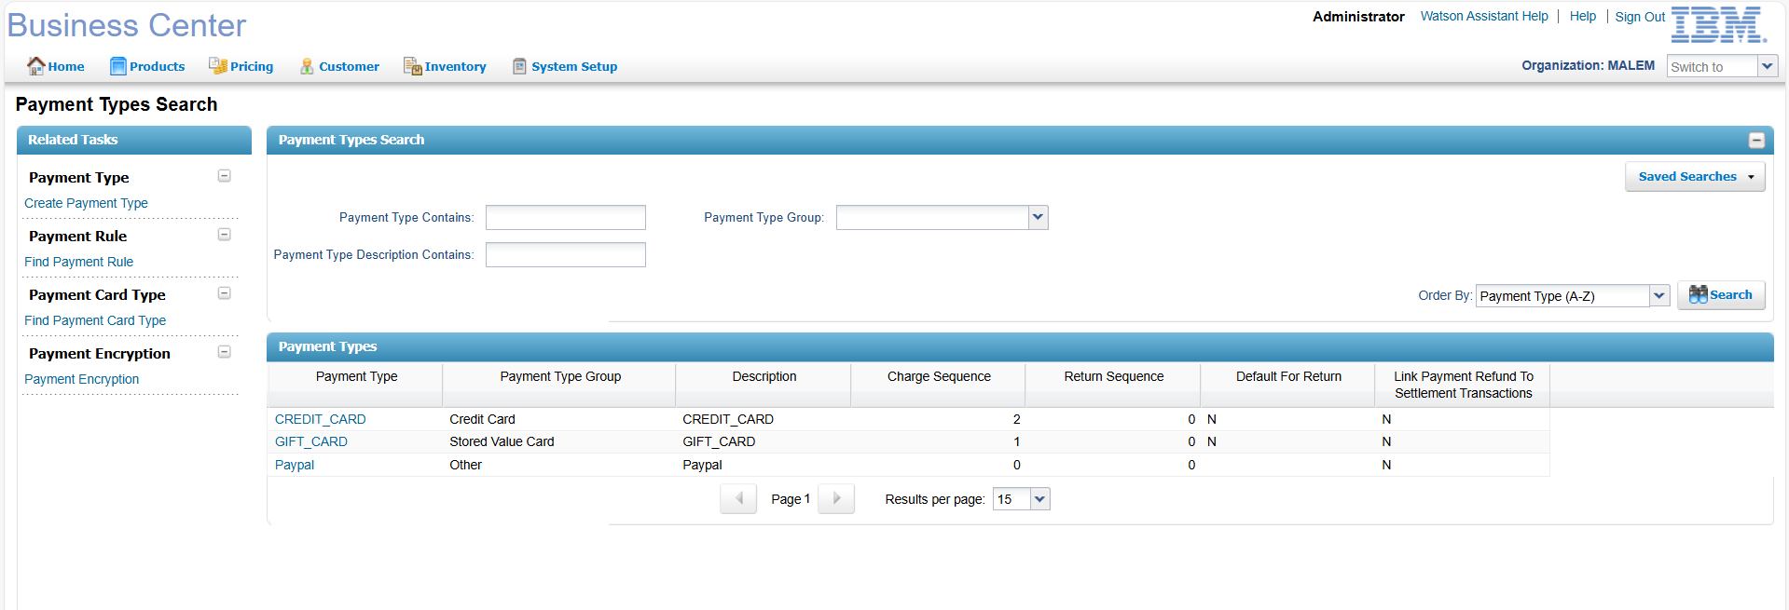

Set Payment Rule in Participant Modelling for MALEM

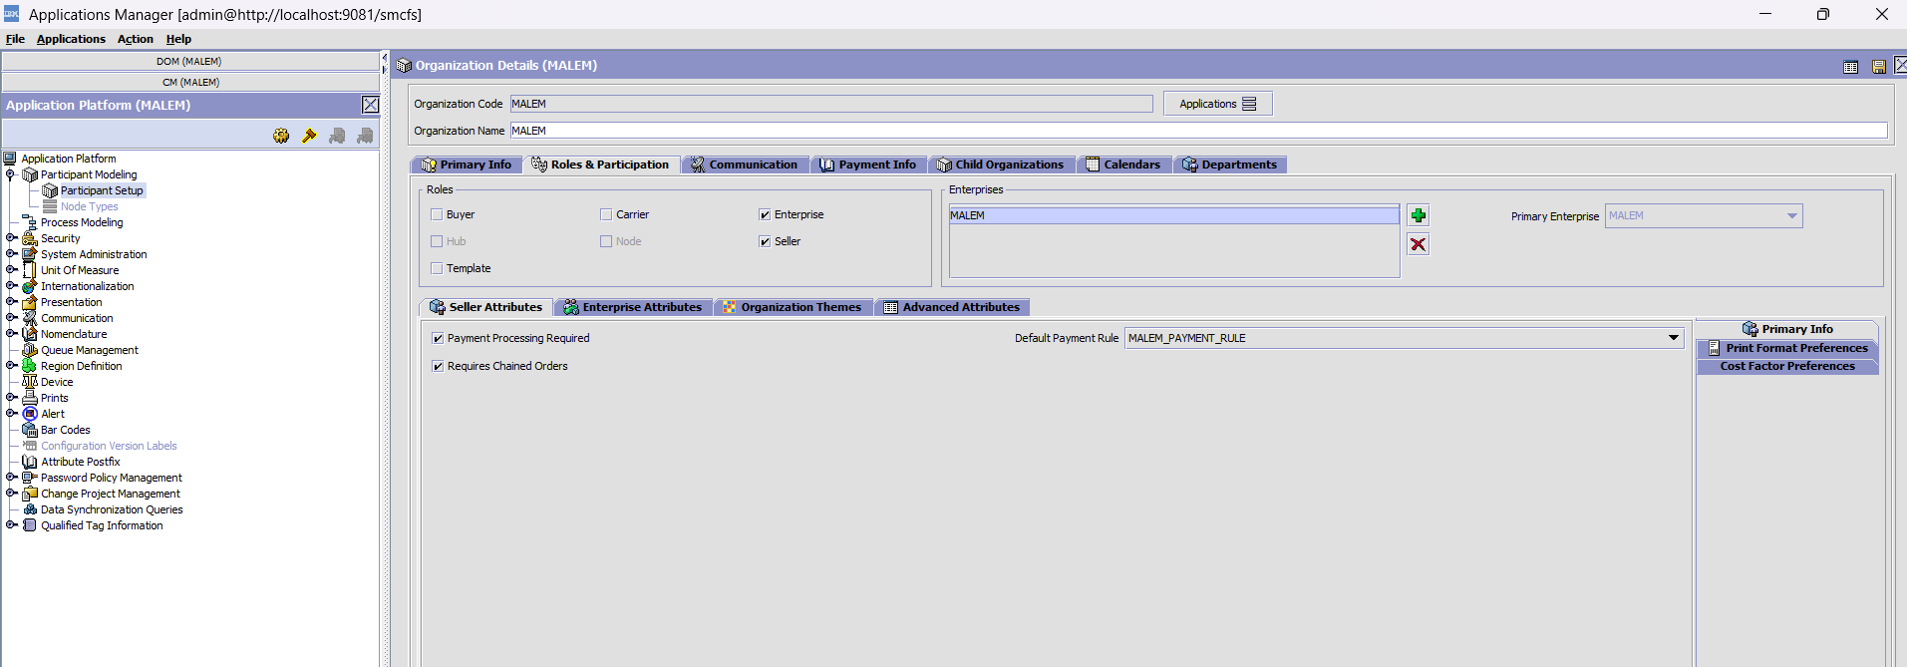

ImplementUserexit

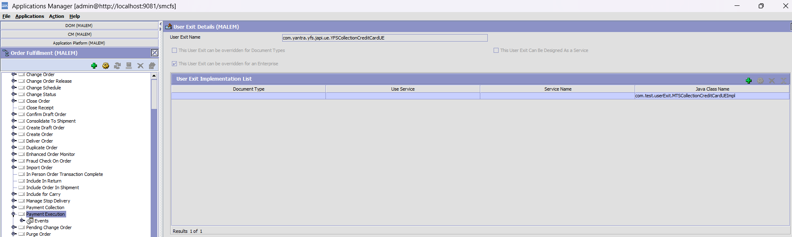

Userexit Code

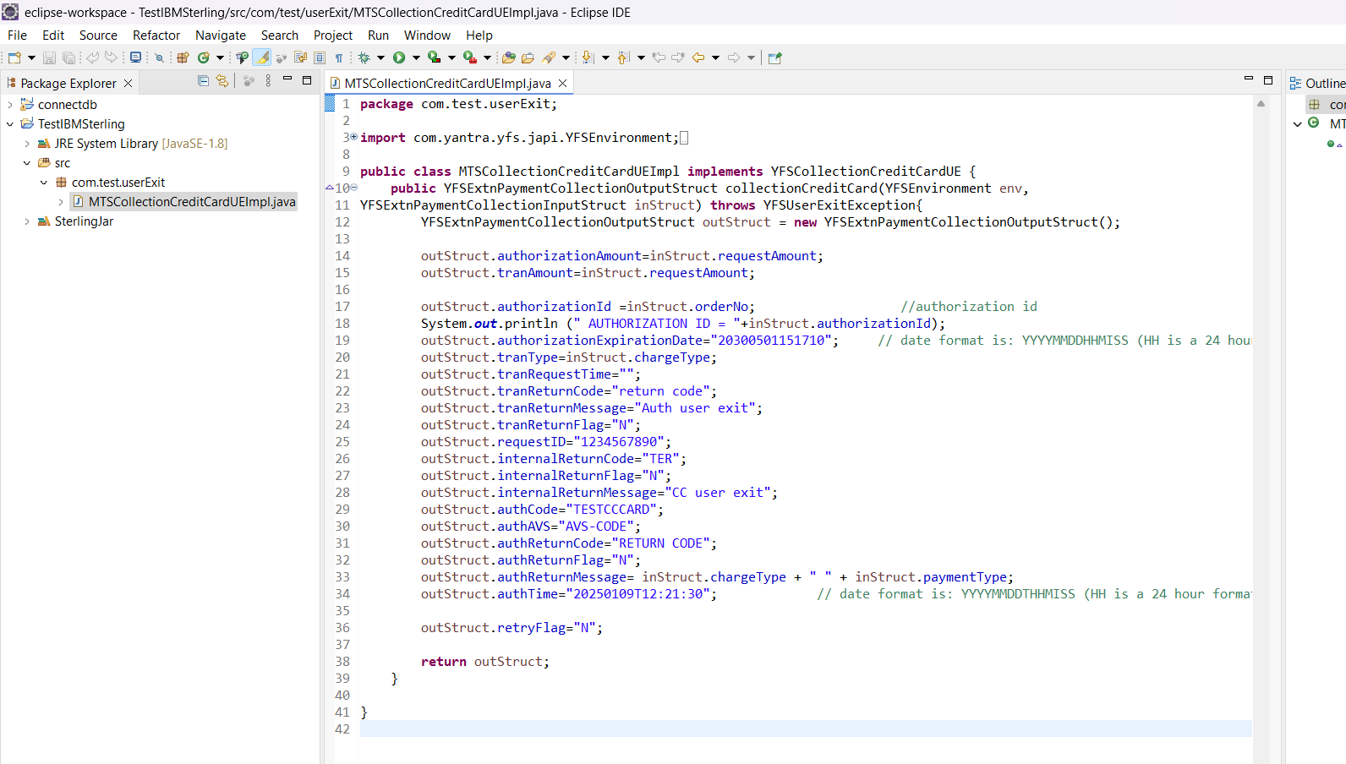

|  |
| --- |
| package com.test.userExit;  import com.yantra.yfs.japi.YFSEnvironment;  import com.yantra.yfs.japi.YFSExtnPaymentCollectionInputStruct;  import com.yantra.yfs.japi.YFSExtnPaymentCollectionOutputStruct;  import com.yantra.yfs.japi.YFSUserExitException;  import com.yantra.yfs.japi.ue.YFSCollectionCreditCardUE;  public class MTSCollectionCreditCardUEImpl implements YFSCollectionCreditCardUE {  public YFSExtnPaymentCollectionOutputStruct collectionCreditCard(YFSEnvironment env,  YFSExtnPaymentCollectionInputStruct inStruct) throws YFSUserExitException{  YFSExtnPaymentCollectionOutputStruct outStruct = new YFSExtnPaymentCollectionOutputStruct();  outStruct.authorizationAmount=inStruct.requestAmount;  outStruct.tranAmount=inStruct.requestAmount;    outStruct.authorizationId =inStruct.orderNo; //authorization id  System.out.println (" AUTHORIZATION ID = "+inStruct.authorizationId);  outStruct.authorizationExpirationDate="20300501151710"; // date format is: YYYYMMDDHHMISS (HH is a 24 hour format).  outStruct.tranType=inStruct.chargeType;  outStruct.tranRequestTime="";  outStruct.tranReturnCode="return code";  outStruct.tranReturnMessage="Auth user exit";  outStruct.tranReturnFlag="N";  outStruct.requestID="1234567890";  outStruct.internalReturnCode="TER";  outStruct.internalReturnFlag="N";  outStruct.internalReturnMessage="CC user exit";  outStruct.authCode="TESTCCCARD";  outStruct.authAVS="AVS-CODE";  outStruct.authReturnCode="RETURN CODE";  outStruct.authReturnFlag="N";  outStruct.authReturnMessage= inStruct.chargeType + " " + inStruct.paymentType;  outStruct.authTime="20250109T12:21:30"; // date format is: YYYYMMDDTHHMISS (HH is a 24 hour format).    outStruct.retryFlag="N";    return outStruct;  }  } |

Export it

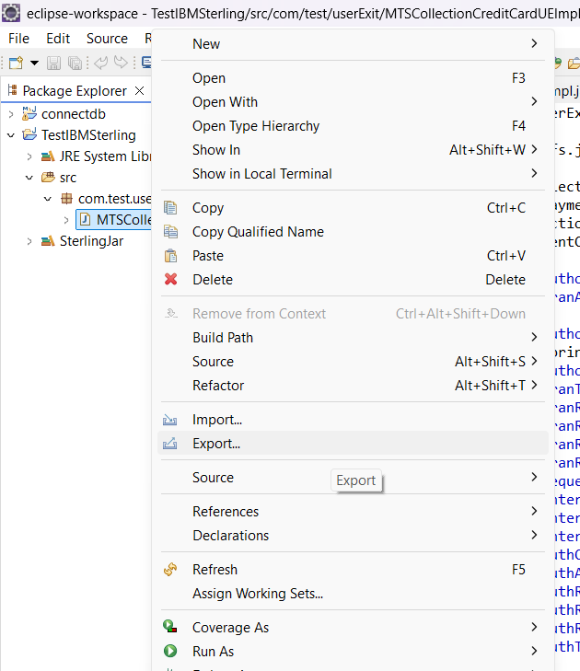

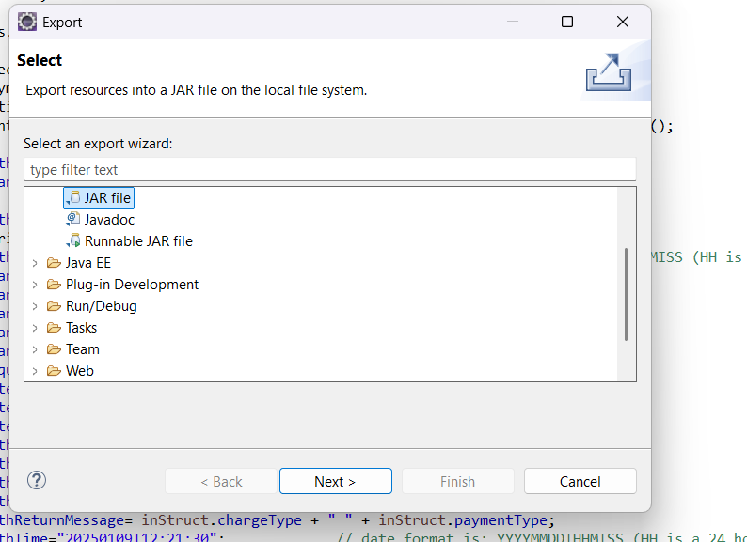

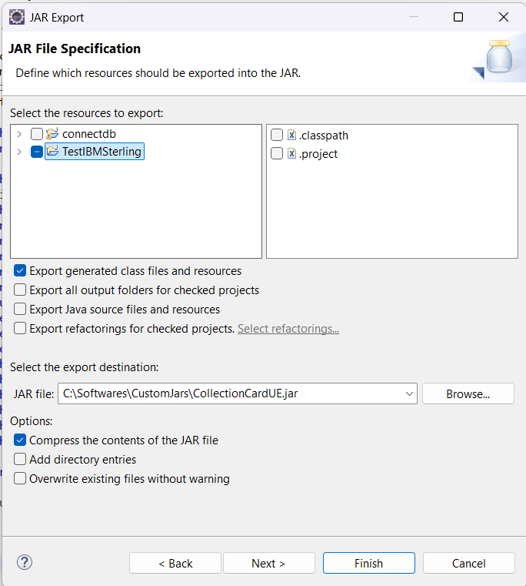

Run the command in <install_dir>\oms10\bin

**install3rdParty.cmd customjar 1 -j C:\Softwares\CustomJars\CollectionCardUE.jar -targetJVM EVERY**

(green color is the path of your jar)

Now build the smcfs

buildwar.cmd -Dappserver=websphere -Dwarfiles=smcfs -Ddevmode=true

deploy it

Create Order

|  |
| --- |
| createOrder  <?xml version="1.0" encoding="UTF-8"?>  <Order DocumentType="0001" EnterpriseCode="MALEM" >  <OrderLines>  <OrderLine OrderedQty="1" PrimeLineNo="1" SubLineNo="1" DeliveryMethod="SHP" ShipNode="Node1" >  <Item ItemID="ITEM1" ProductClass="NEW" UnitOfMeasure="EACH" />  <LinePriceInfo UnitPrice="10" />  </OrderLine>  </OrderLines>  <PaymentMethods>  <PaymentMethod ChargeSequence="1" CreditCardExpDate="20251010" CreditCardName="" CreditCardNo="1111111111" CreditCardType="VISA" PaymentType="CREDIT_CARD" SvcNo="" UnlimitedCharges="Y">  </PaymentMethod>  </PaymentMethods>  <PersonInfoShipTo FirstName="Ruchi" LastName="Kum" AddressLine1="pune" AddressLine2="city" EMailID="ruchi.kum@gmail.com" City="Pune" State="TN" ZipCode="432124" Country="IN" />  <PersonInfoBillTo FirstName="Ruchi" LastName="Kum" AddressLine1="pune" AddressLine2="city" EMailID="ruchi.kum@gmail.com" City="Pune" State="TN" ZipCode="432124" Country="IN" />  </Order> |

select * from yfs_charge_transaction where Order_header_key IN (select order_header_key from yfs_order_header where order_no='Y100000513');

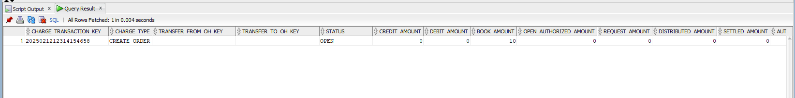

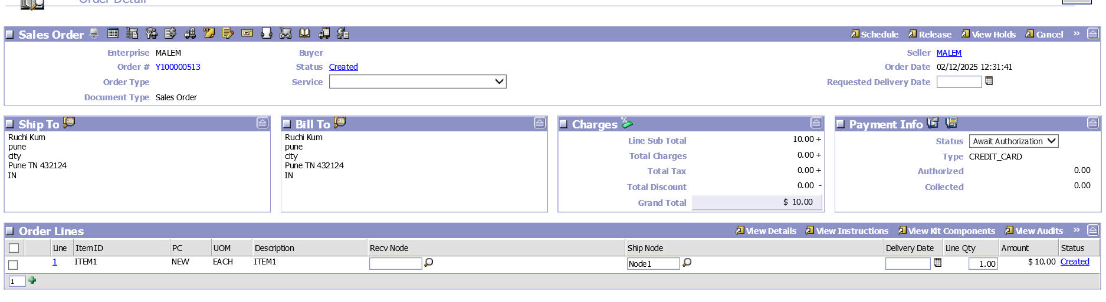

**requestCollection**

<Order DocumentType="0001" EnterpriseCode="MALEM" OrderHeaderKey="2025021212314154653" OrderNo="Y100000513"/>

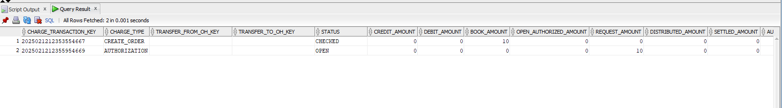

**executeCollection**

<Order DocumentType="0001" EnterpriseCode="MALEM" OrderHeaderKey="2025021212314154653" OrderNo="Y100000513"/>

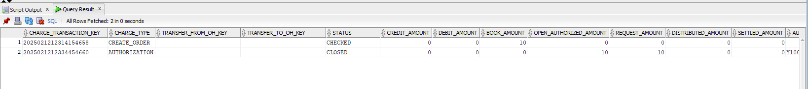

**requestcollection**

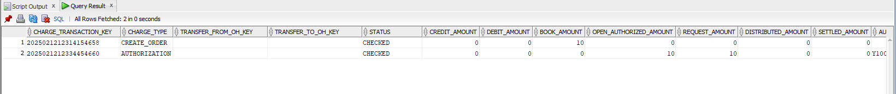

scheduleOrder

releaseOrder

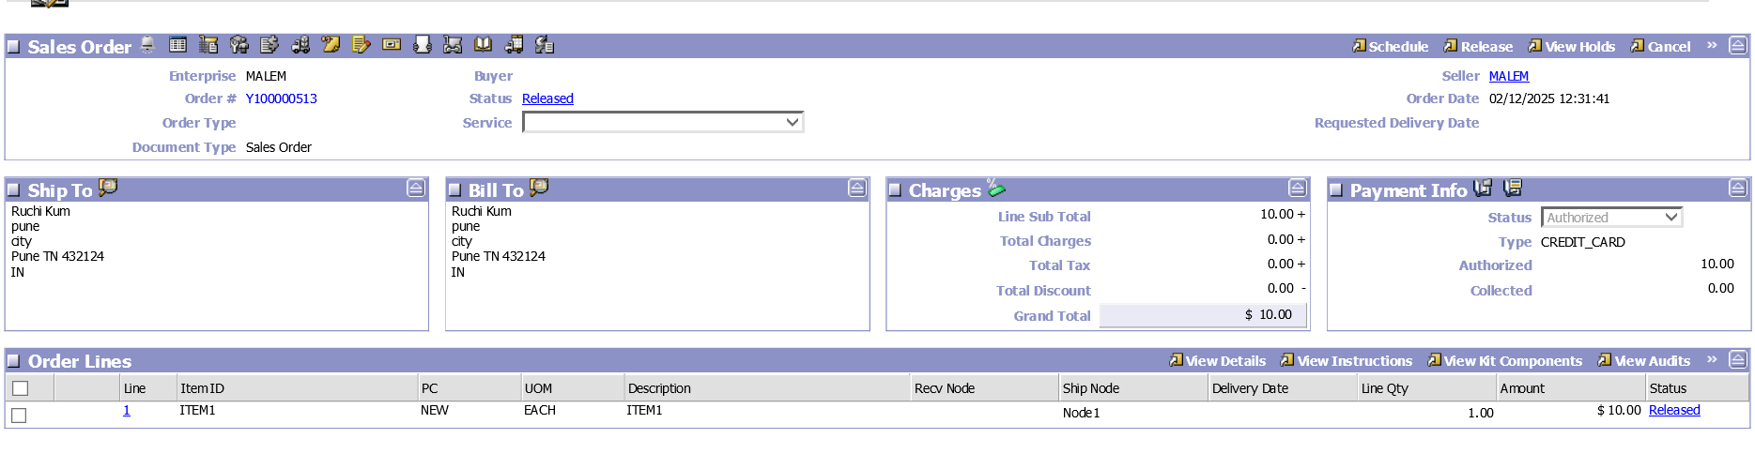

getOrderList Template

|  |
| --- |
| <OrderList>  <Order OrderNo="">  <OrderStatuses>  <OrderStatus OrderHeaderKey="" OrderReleaseKey="" >  </OrderStatus>  </OrderStatuses>  </Order>  </OrderList> |

confirmShipment

|  |
| --- |
| <Shipment DocumentType="0001" EnterpriseCode="MALEM" ProNo="123">  <ShipmentLines>  <ShipmentLine OrderNo="Y100000513" OrderReleaseKey="2025021212372854674" PrimeLineNo="1" ProductClass="NEW" Quantity="1" SubLineNo="1" UnitOfMeasure="EACH">  </ShipmentLine>  </ShipmentLines>  </Shipment> |

createShipmentInvoice

|  |
| --- |
| <Shipment ShipmentKey="2025021213401356224" TransactionId="CREATE_SHMNT_INVOICE.0001"/> |

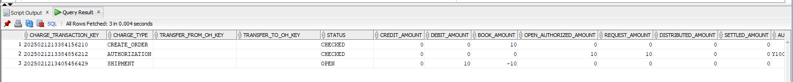

requestCollection

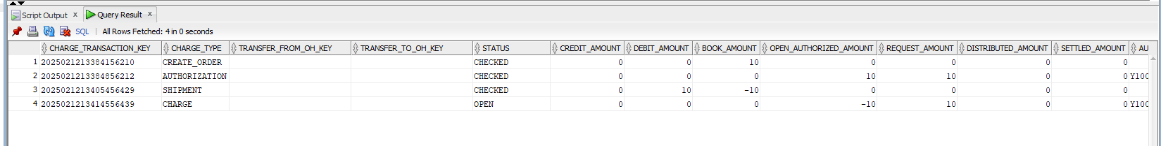

executeCollection

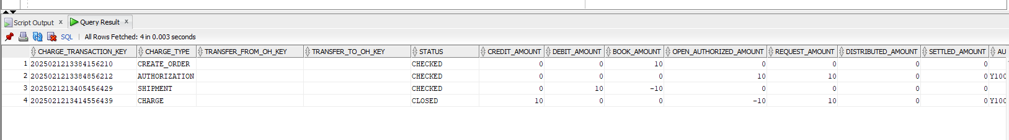

requestCollection

